**HTML AND CSS**

**PROGRAM 1**

<!DOCTYPE ht<!DOCTYPE html>

<html>

<body>

<h2>HTML Buttons</h2>

<p>HTML buttons are defined with the button tag:</p>

<button>Click me</button>

</body>

</html>

**OUTPUT**

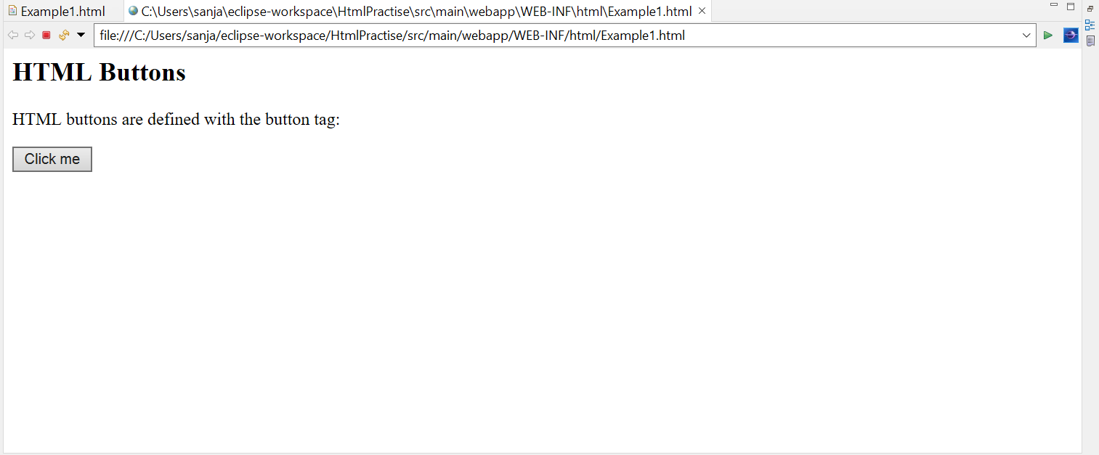

**PROGRAM 2**

<!DOCTYPE html>

<html>

<body>

<h2>HTML Images</h2>

<p>HTML images are defined with the img tag:</p>

<img src=*"C:\Users\sanja\OneDrive\Desktop\Canva\Harry Styles\LOVE ON TOUR.png"* alt=*"LOVE ON TOUR.com"* width=*"270"* height=*"170"*>

</body>

</html>

**OUTPUT**

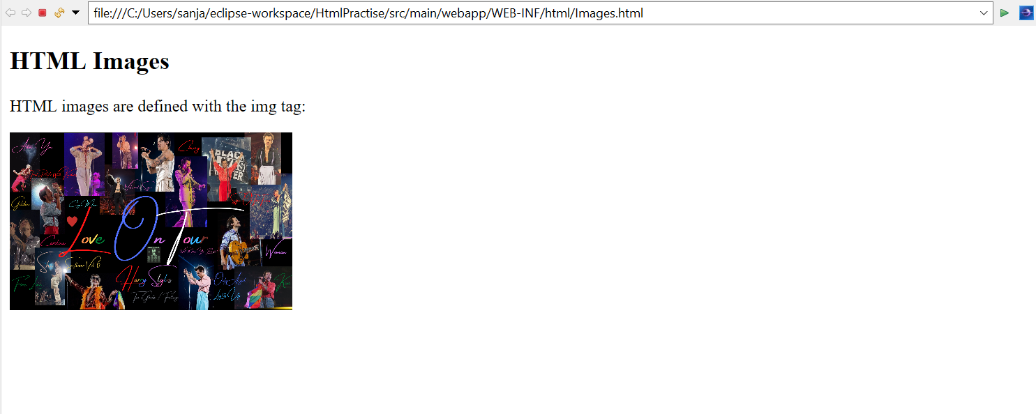

**PROGRAM 3**

<!DOCTYPE html>

<html>

<body>

<h2>An Unordered HTML List</h2>

<ul>

<li>Coffee</li>

<li>Tea</li>

<li>Milk</li>

</ul>

<h2>An Ordered HTML List</h2>

<ol>

<li>Coffee</li>

<li>Tea</li>

<li>Milk</li>

</ol>

</body>

</html>

**OUTPUT**

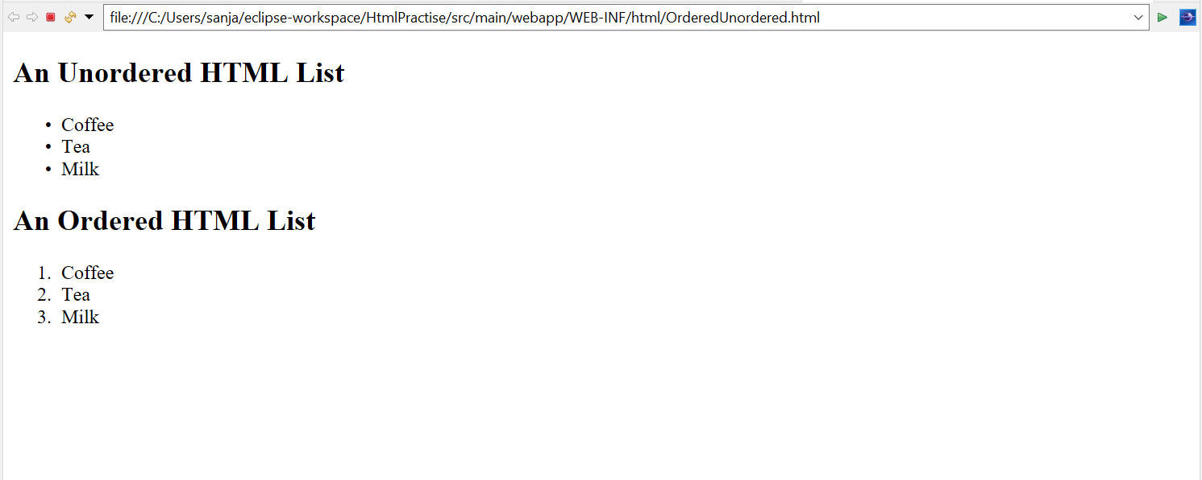

**PROGRAM 4**

<!DOCTYPE html>

<html>

<body>

<h2>Width and Height Attributes</h2>

<p>The width and height attributes of the img tag, defines the width and height of the image:</p>

<img src=*"C:\Users\sanja\OneDrive\Desktop\Canva\Mamamoo\__Mamamoo__.png"* width=*"500"* height=*"450"*>

</body>

</html>

**OUTPUT**

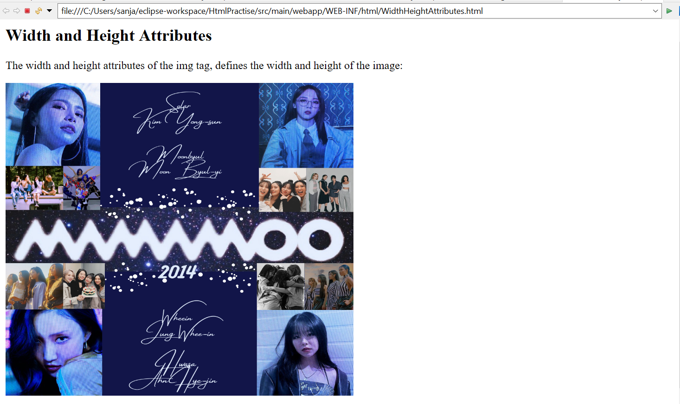

**PROGRAM 5**

<!DOCTYPE html>

<html>

<body>

<p>This is<br>a paragraph<br>with line breaks.</p>

</body>

</html>

**OUTPUT**

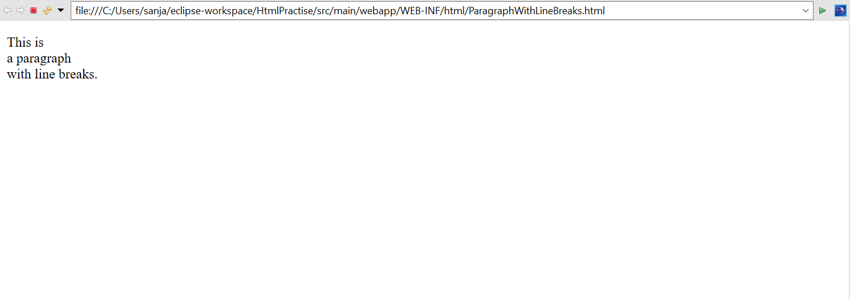

**PROGRAM 6**

<!DOCTYPE html>

<html>

<body>

<h1 style="color:*blue*;">This is a heading</h1>

<p style="color:*red*;">This is a paragraph.</p>

</body>

</html>

**OUTPUT**

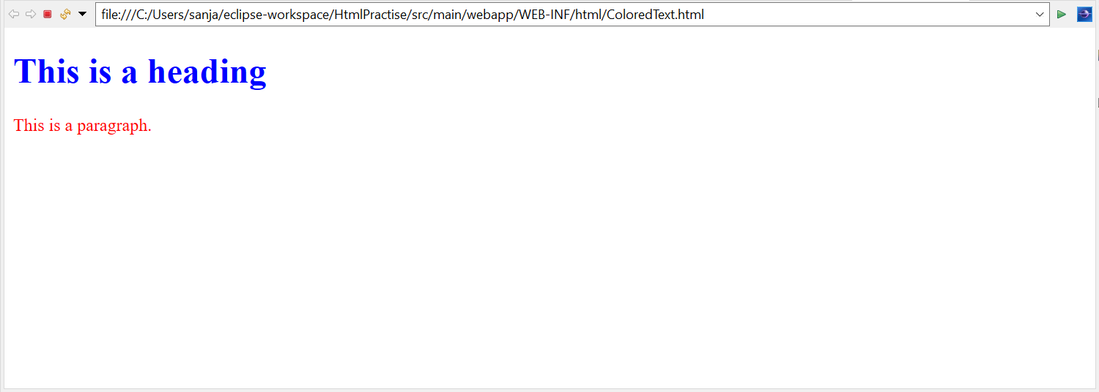

**PROGRAM 7**

<!DOCTYPE html>

<html>

<body>

<p>My favorite color is <del>blue</del> red.</p>

</body>

</html>

**OUTPUT**

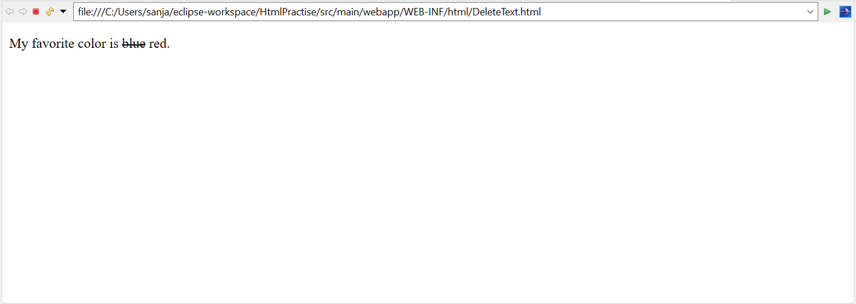

**PROGRAM 8**

<!DOCTYPE html>

<html>

<body>

<p>My favorite color is <del>blue</del> <ins>red</ins>.</p>

</body>

</html>

**OUTPUT**

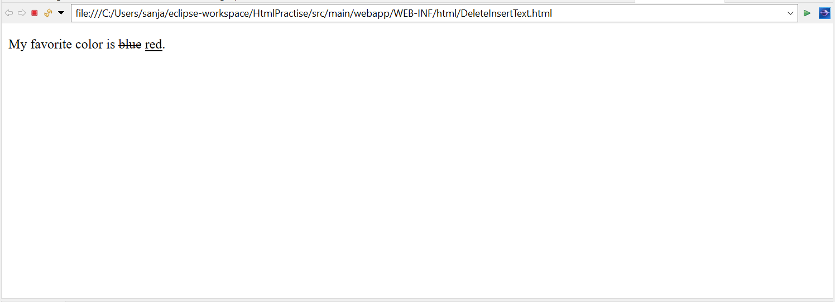

**PROGRAM 9**

<!DOCTYPE html>

<html>

<head>

<style>

**body** {background-color: *powderblue*;}

**h1** {color: *blue*;}

**p** {color: *red*;}

</style>

</head>

<body>

<h1>This is a heading</h1>

<p>This is a paragraph.</p>

</body>

</html>

**OUTPUT**

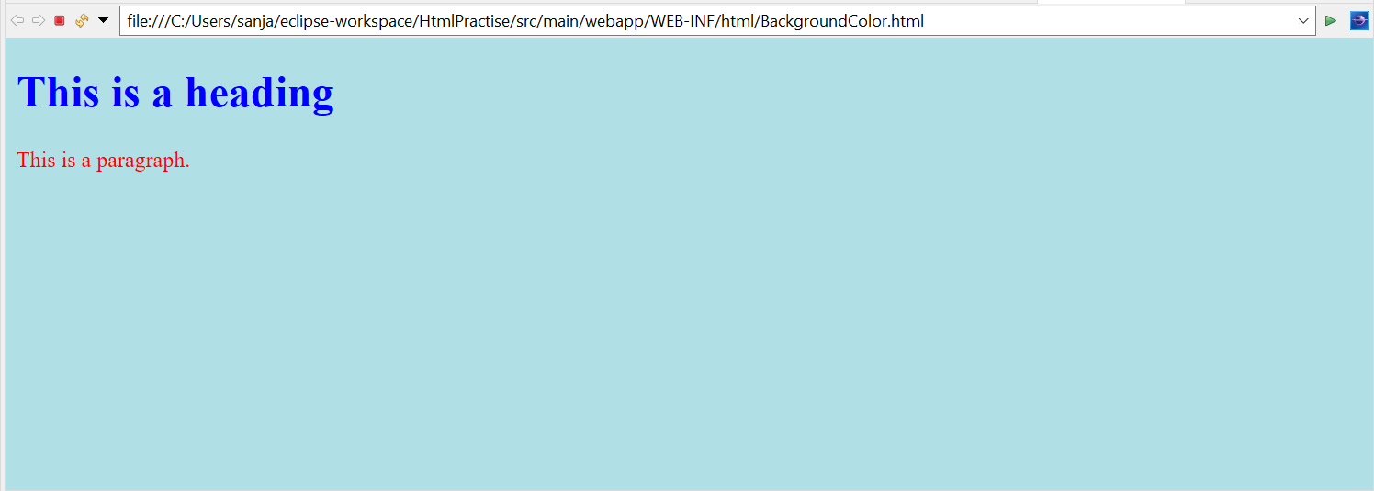

**PROGRAM 10**

<!DOCTYPE html>

<html>

<head>

<link rel=*"stylesheet"* href=*"styles.css"*>

</head>

<body>

<h1>This is a heading</h1>

<p>This is a paragraph.</p>

</body>

</html>

**OUTPUT**

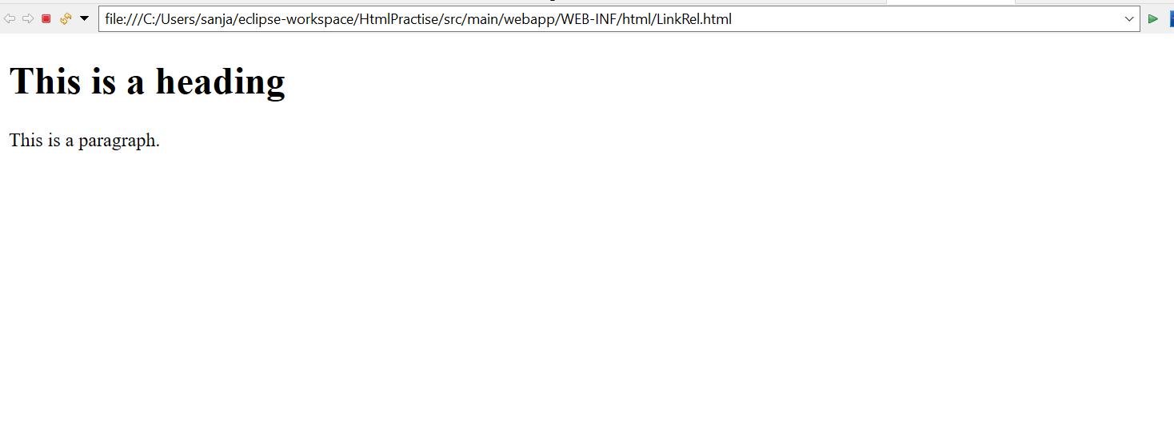

**PROGRAM 11**

<!DOCTYPE html>

<html>

<head>

<style>

**p** {

border: *2px solid powderblue*;

}

</style>

</head>

<body>

<h1>This is a heading</h1>

<p>This is a paragraph.</p>

<p>This is a paragraph.</p>

<p>This is a paragraph.</p>

</body>

</html>

**OUTPUT**

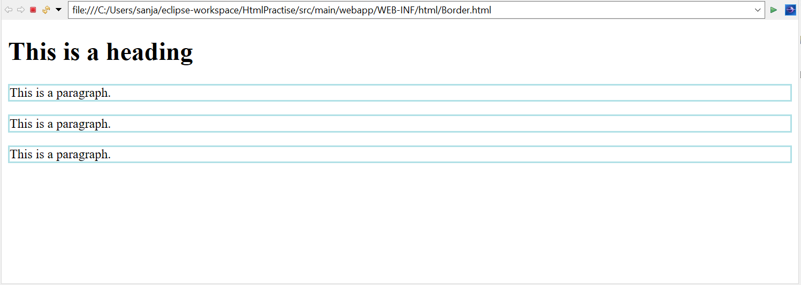

**PROGRAM 12**

<!DOCTYPE html>

<html>

<head>

<style>

**table,** **th,** **td** {

border: *1px solid black*;

border-collapse: *collapse*;

}

**th,** **td** {

padding: *5px*;

}

</style>

</head>

<body>

<table>

<tr>

<td>

<p>This is a paragraph</p>

<p>This is another paragraph</p>

</td>

<td>This cell contains a table:

<table>

<tr>

<td>A</td>

<td>B</td>

</tr>

<tr>

<td>C</td>

<td>D</td>

</tr>

</table>

</td>

</tr>

<tr>

<td>This cell contains a list

<ul>

<li>apples</li>

<li>bananas</li>

<li>pineapples</li>

</ul>

</td>

<td>HELLO</td>

</tr>

</table>

</body>

</html>

**OUTPUT**

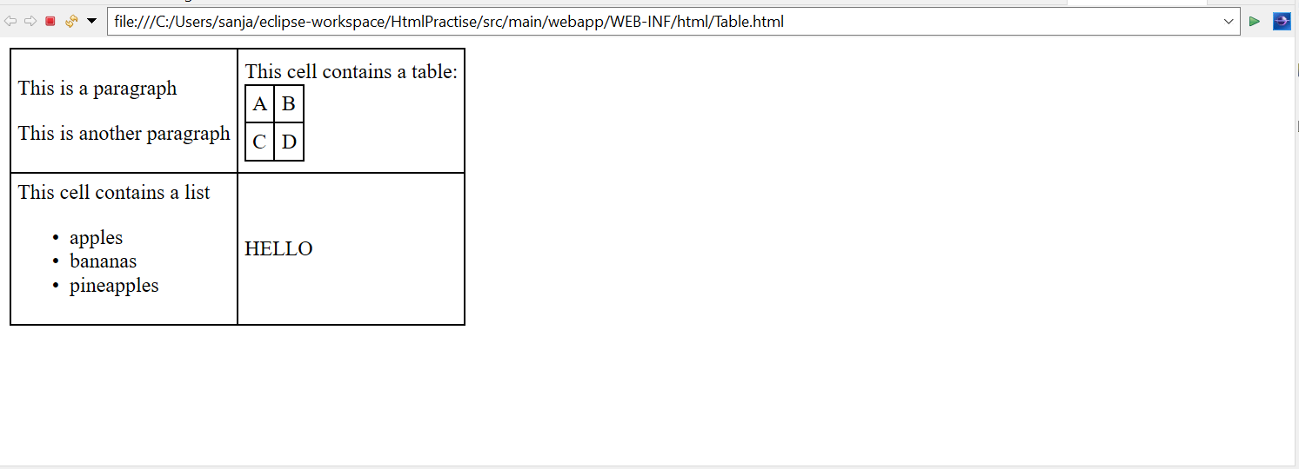

**PROGRAM 13**

<!DOCTYPE html>

<html>

<body>

<h2>Ordered List with Letters</h2>

<ol type=*"A"*>

<li>Coffee</li>

<li>Tea</li>

<li>Milk</li>

</ol>

</body>

</html>

**OUTPUT**

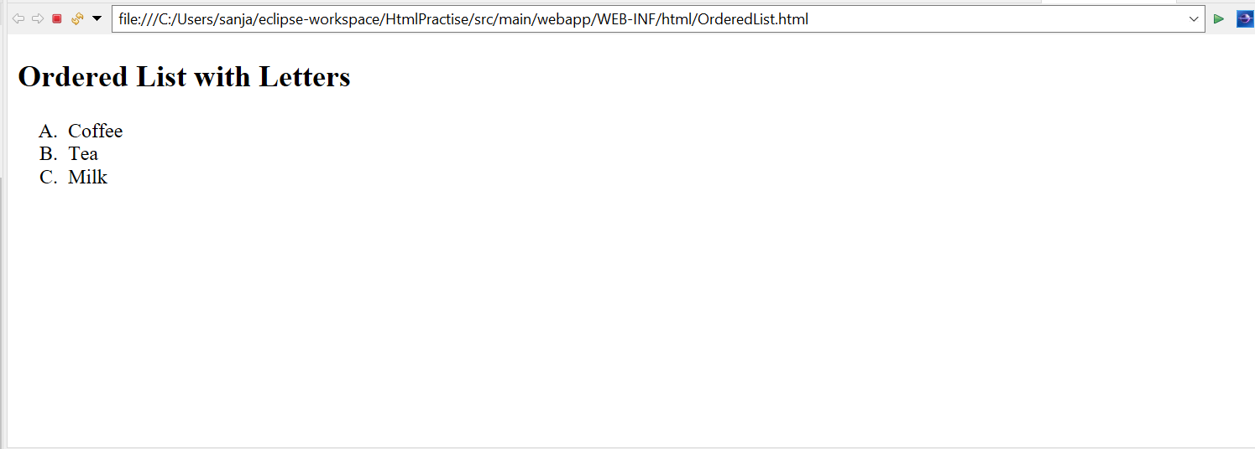

**PROGRAM 14**

<!DOCTYPE html>

<html>

<body>

<div style="background-color:*black*;color:*white*;padding:*20px*;">

<h2>London</h2>

<p>London is the capital city of England. It is the most populous city in the United Kingdom, with a metropolitan area of over 13 million inhabitants.</p>

<p>Standing on the River Thames, London has been a major settlement for two millennia, its history going back to its founding by the Romans, who named it Londinium.</p>

</div>

</body>

</html>

**OUTPUT**

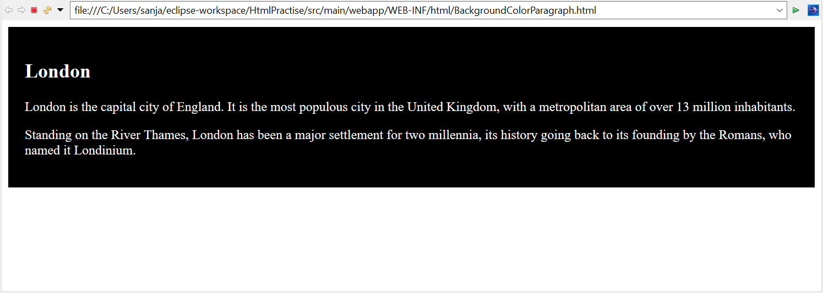

**PROGRAM 15**

<!DOCTYPE html>

<html>

<body>

<h2>HTML Iframes</h2>

<p>An iframe is used to display a web page within a web page:</p>

<iframe src=*"https://www.w3schools.com/html/"*></iframe>

</body>

</html>

**OUTPUT**

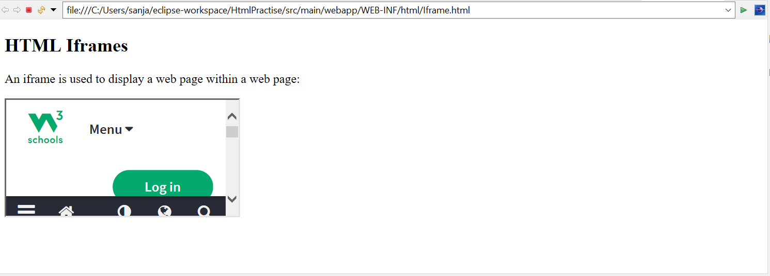

**PROGRAM 16**

<!DOCTYPE html>

<html>

<body>

<h2>HTML Forms</h2>

<form action=*"/action_page.php"*>

<label for=*"fname"*>First name:</label><br>

<input type=*"text"* id=*"fname"* name=*"fname"* value=*"John"*><br>

<label for=*"lname"*>Last name:</label><br>

<input type=*"text"* id=*"lname"* name=*"lname"* value=*"Doe"*><br><br>

<input type=*"submit"* value=*"Submit"*>

</form>

<p>If you click the "Submit" button, the form-data will be sent to a page called "/action_page.php".</p>

</body>

</html>

**OUTPUT**

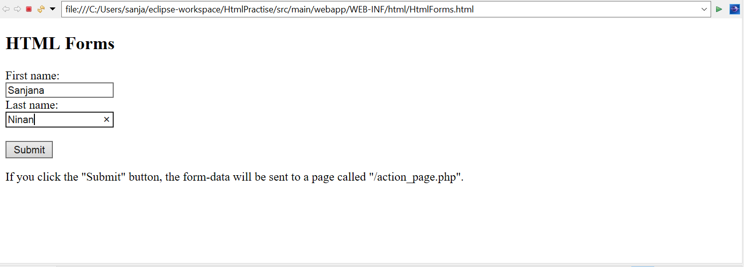

**PROGRAM 17**

<!DOCTYPE html>

<html>

<body>

<h2>Date Field</h2>

<p>The <strong>input type="date"</strong> is used for input fields that should contain a date.</p>

<form action=*"/action_page.php"*>

<label for=*"birthday"*>Birthday:</label>

<input type=*"date"* id=*"birthday"* name=*"birthday"*>

<input type=*"submit"* value=*"Submit"*>

</form>

<p><strong>Note:</strong> type="date" is not supported in Internet Explorer 11 or prior Safari 14.1.</p>

</body>

</html>

**OUTPUT**

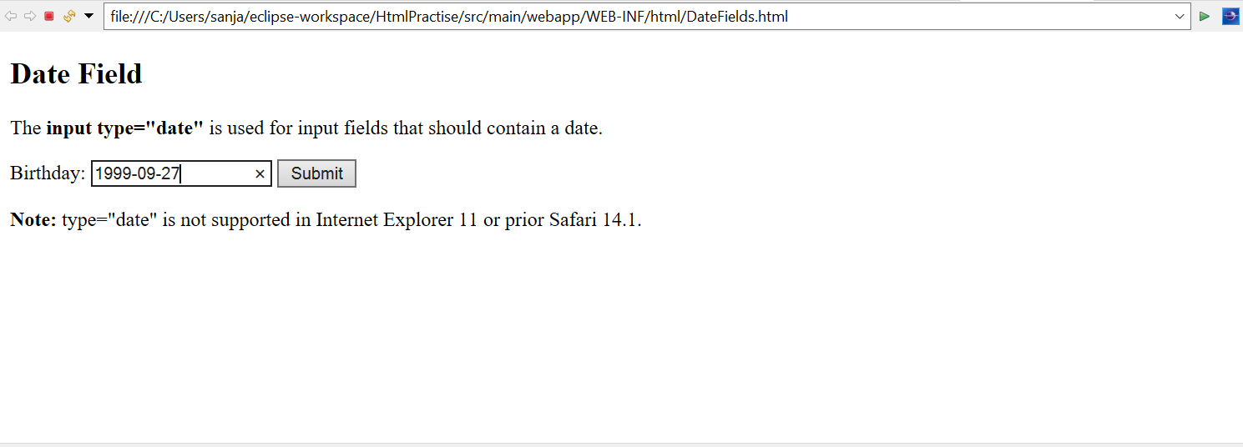

**PROGRAM 18**

<!DOCTYPE html>

<html>

<body>

<h2>Checkboxes</h2>

<p>The <strong>input type="checkbox"</strong> defines a checkbox:</p>

<form action=*"/action_page.php"*>

<input type=*"checkbox"* id=*"vehicle1"* name=*"vehicle1"* value=*"Bike"*>

<label for=*"vehicle1"*> I have a bike</label><br>

<input type=*"checkbox"* id=*"vehicle2"* name=*"vehicle2"* value=*"Car"*>

<label for=*"vehicle2"*> I have a car</label><br>

<input type=*"checkbox"* id=*"vehicle3"* name=*"vehicle3"* value=*"Boat"*>

<label for=*"vehicle3"*> I have a boat</label><br><br>

<input type=*"submit"* value=*"Submit"*>

</form>

</body>

</html>

**OUTPUT**

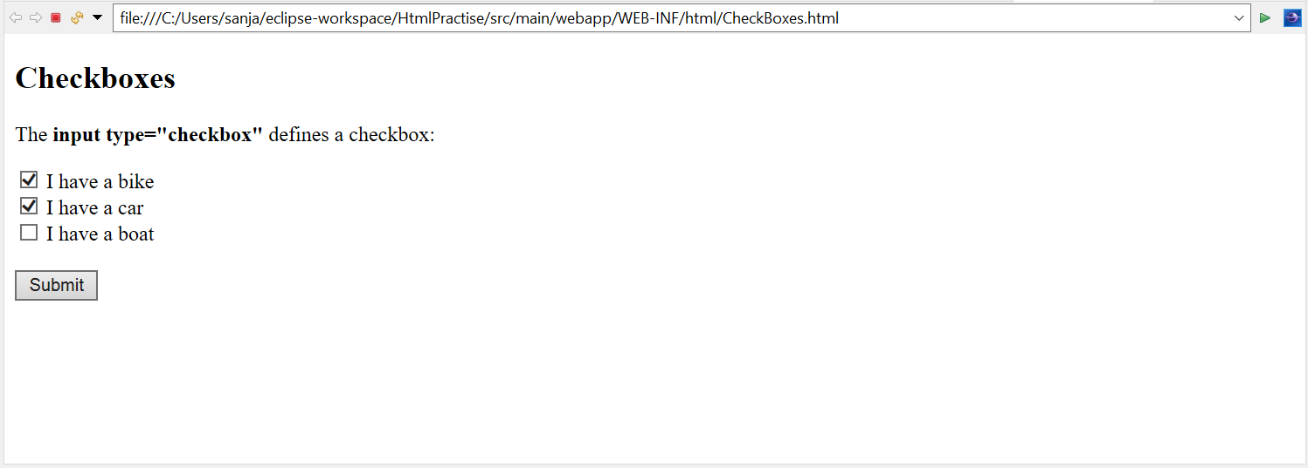

**PROGRAM 19**

<!DOCTYPE html>

<html>

<body>

<h2>My First Web Page</h2>

<p>My first paragraph.</p>

<p>Never call document.write after the document has finished loading.

It will overwrite the whole document.</p>

<script>

document.write(5 + 6);

</script>

</body>

</html>

**OUTPUT**

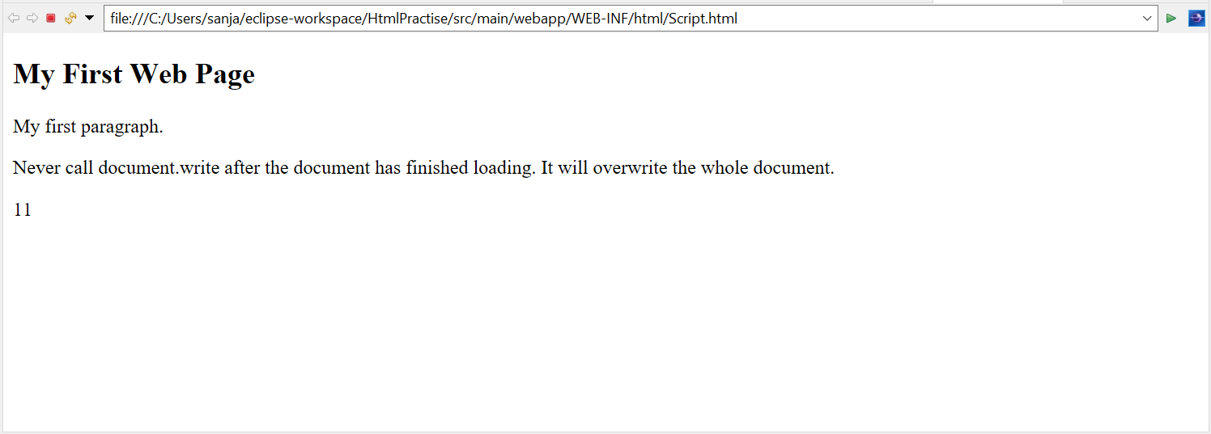

**PROGRAM 20**

<!DOCTYPE html>

<html>

<body>

<h2>JavaScript Expressions</h2>

<p>Expressions compute to values.</p>

<p id=*"demo"*></p>

<script>

document.getElementById("demo").innerHTML = 5 * 10;

</script>

</body>

</html>

**OUTPUT**

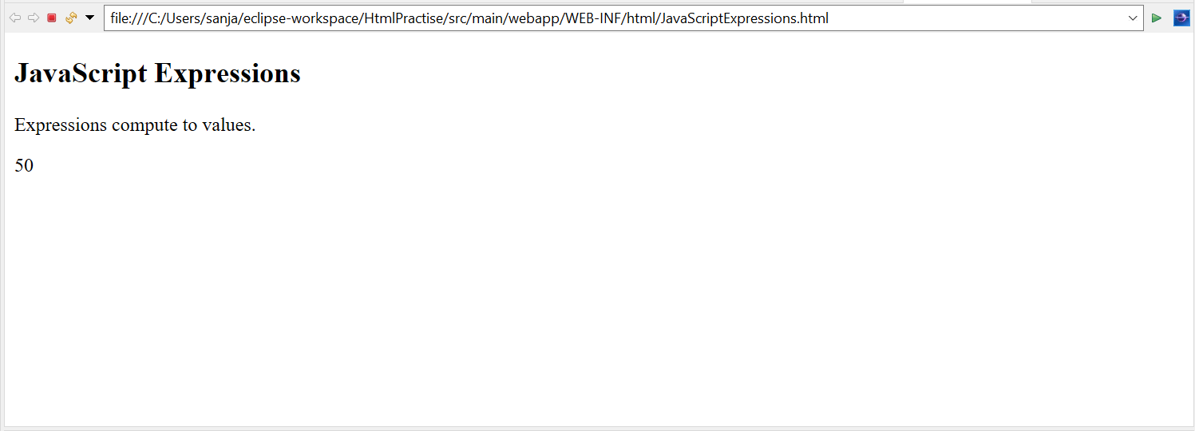

**PROGRAM 21**

<!DOCTYPE html>

<html>

<body>

<h2>JavaScript Functions</h2>

<p>This example calls a function which performs a calculation and returns the result:</p>

<p id=*"demo"*></p>

<script>

**var** x = myFunction(4, 3);

document.getElementById("demo").innerHTML = x;

**function** myFunction(a, b) {

**return** a * b;

}

</script>

</body>

</html>

**OUTPUT**

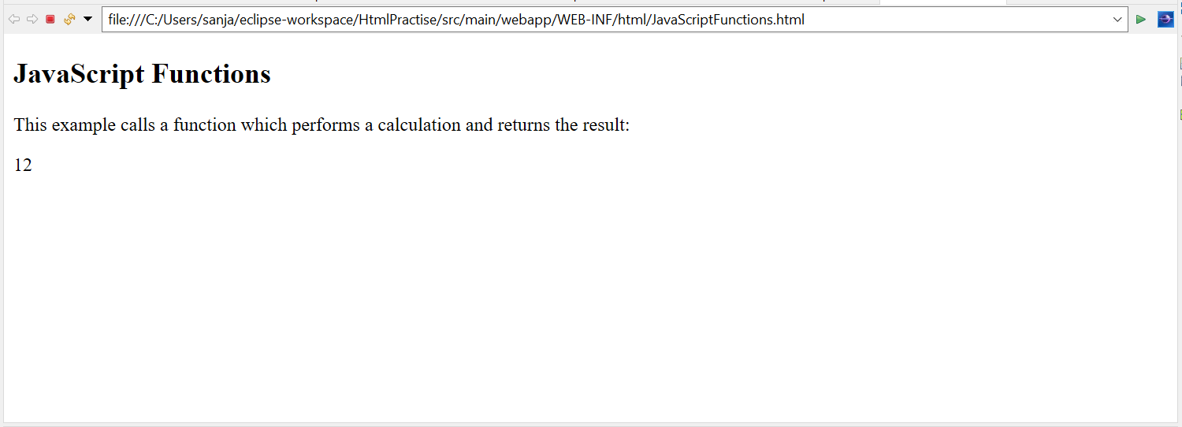

**PROGRAM 22**

<!DOCTYPE html>

<html>

<body>

<h2>JavaScript String Methods</h2>

<p>Display the first array element, after a string split:</p>

<p id=*"demo"*></p>

<script>

let text = "a,b,c,d,e,f";

**const** myArray = text.split(",");

document.getElementById("demo").innerHTML = myArray[0];

</script>

</body>

</html>

**OUTPUT**

